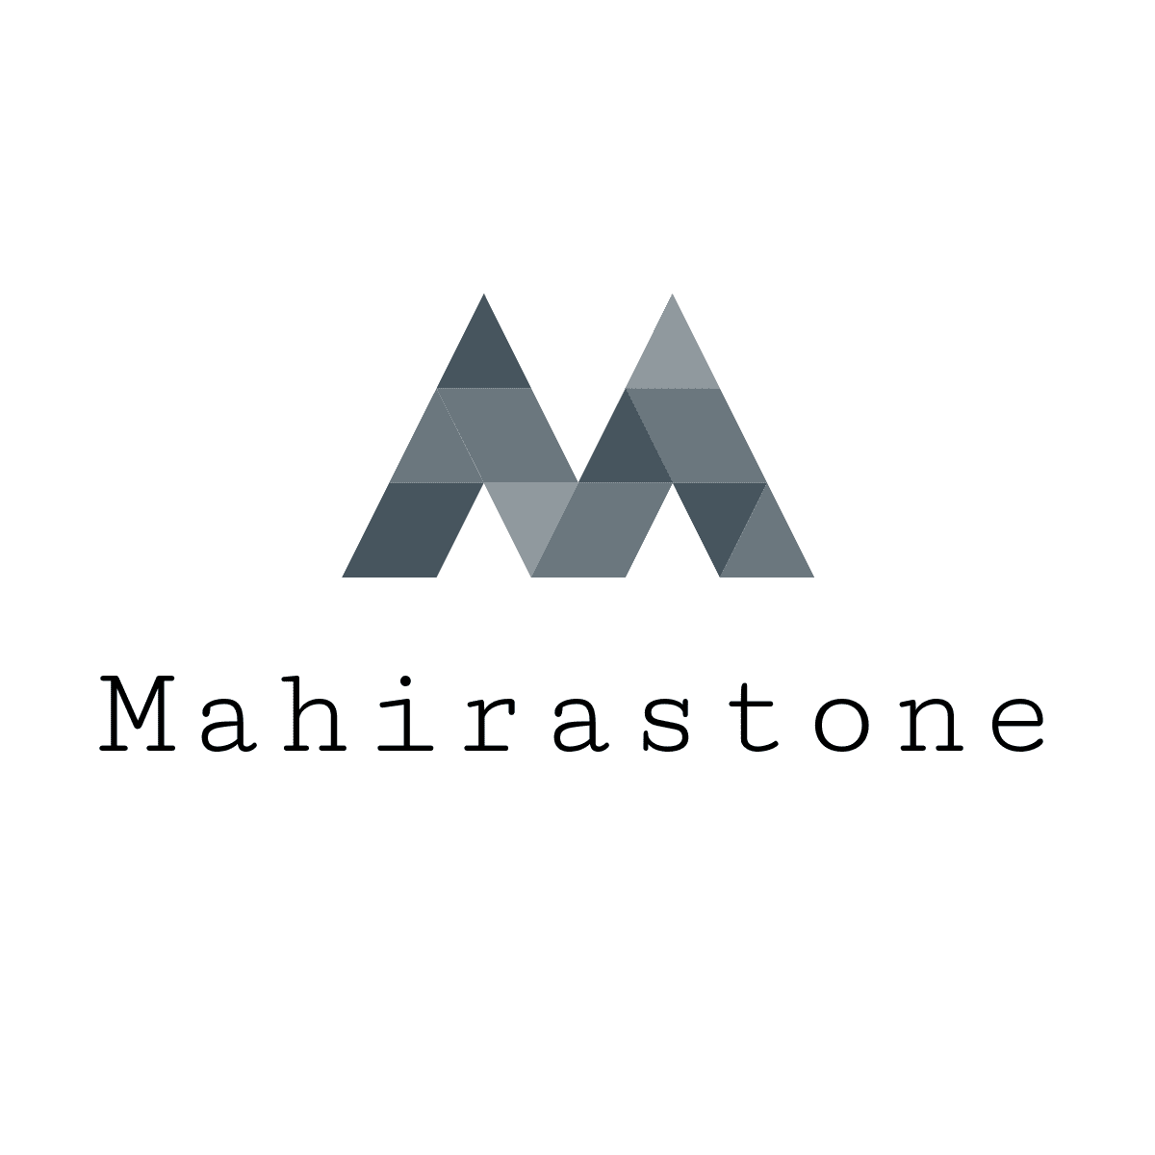

Sc by 2011 Co/Founder by Dishu Mangukiya

Emial- [Mahirastone403@gmail.com](mailto:Mahirastone403@gmail.com)

Addres-

1. Surat Manufacturing Facility

A-52 Mohan Nagar, Surat Gujrat

India

1. Mahirastone Germany Inc.

Hof, 95028

Germany

ARE YOU LOOKING FOR THE PERFECT DIAMOND? GET IN TOUCH

About US

Mahirastone is an Indian company that was founded in 2011 and has its headquarters and manufacturing hub in Surat. Mahirastone is a Natural Diamond Manufacturer, setting standards not just for the sheer size of its activities, but also for product quality, precision, and diversity, technological integration, production, and broader social responsibility.

Our product offers, too, bear the Mahirastone stamp, with an emphasis on both breadth and beauty.

We provide clients with an unrivalled selection of items in round, pears, marquise, princess, emerald, cushion, and heart shaped diamonds. A wide range of sizes, grades, and packaging are available. A mix of certified and non-certified products. Sizes ranging from 1 carat to 3 carats. There are several certification choices. Extensive stockpiles and a wide range of varied packages

The rough diamonds used are 100% natural and obtained solely from ethical sources. Manufacturing takes place under rigorous supervision at our cutting-edge manufacturing facility.

Mahirastone success may be attributed to its ethical business methods as well as meeting the needs of its consumers on demand.